**Focus Keyword: Cyber Background Check**

**Meta Title: Cyber Background Check | Educatecast**

**Meta Description:** Cyber Background Check is a website (cyberbackgroundchecks.com) that allows internet users to do semi-thorough background checks on persons.

**Feature Image:**

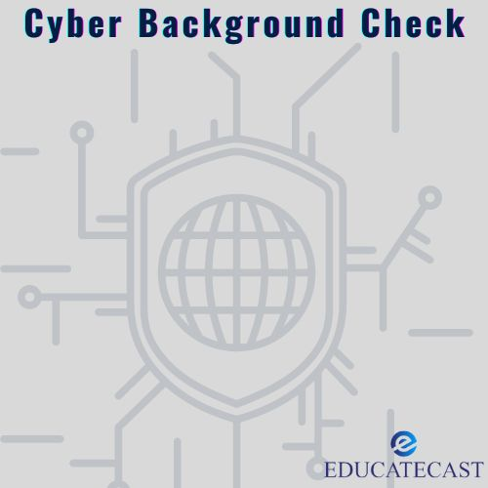

**Cyber Background Check**

Cyber Background Check is a website (cyberbackgroundchecks.com) that allows internet users to do semi-thorough background checks on persons. This website was launched in 2019 and currently has a domain authority score of 14.

It's a people search engine that searches for and shows extensive information about people. This information, however, is not intended to be utilized for FCRA reasons.

**Fair Credit Reporting Act (FCRA)**

The Fair Credit Reporting Act (FCRA) is federal legislation in the United States that promotes the accuracy, impartiality, and privacy of data used by consumer reporting agencies. Credit bureaus and financial institutions are examples of consumer reporting companies that collect, retain, utilize, and distribute customer information for use in background checks.

**Cyber Background Check Characteristics**

A single search can reveal facts such as a person's past and new residences, social media accounts, old and new phone numbers, prospective business assets, criminal history, family members, business partners, email addresses, known aliases, and a plethora of other information.

**Home Page for Cyber Background Checks**

Visitors could look for people by their first and last name, mailing address, phone number, or email address. And they may come upon the following record in the CyberBackgroundChecks.com database.

* Addresses, both current and historical
* Any aliases discovered?
* Phone numbers, both current and historical
* Potential relatives and associates
* Possibility of business ownership and assets

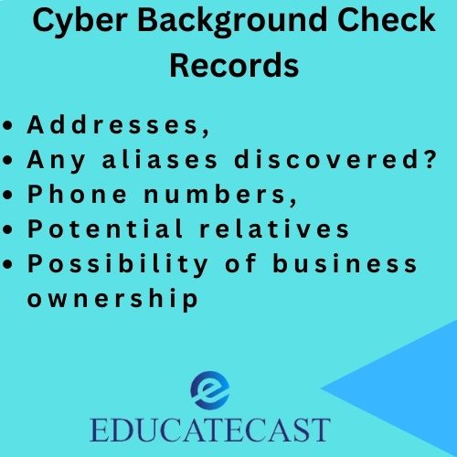

**How Does a Cyber Background Check Work?**

The Cyber Background Check program learns about a person by compiling and collecting information from official public records.

To get information about a person on the site, simply enter the individual's first and last name, phone number, email address, and postal address into the Cyber Background Checks search engine.

Other identifying characteristics, such as their city or state of residence, may be provided to restrict results and make your search more exact.

However, typos, misspellings, and other human mistakes are conceivable in public documents.

As a consequence, double-checking information found on a website is always a smart idea, especially if it's critical to making a decision.

Apart from their amount of depth, the finest thing about Cyber Background Checks is their ease of use.

The site is ideal for reuniting with long-lost relatives or acquaintances, as well as obtaining information on an unknown number that called you.

Many individuals go a step farther, using the app to do background checks on employers, workers, and even tenants.

In relation to the latter, the website warns against utilising its services for Fair Credit Reporting Act (FCRA) reasons. However, Cyber Background Checks and similar websites are not without flaws.

For one thing, if you can get such thorough information about other individuals on the website, you can be certain that such detailed information exists on you as well. It is unnecessary to underscore how dangerous this is. Fortunately, you may get your information removed from Cyber Background Checks.

**When Using a Cyber Background Check for Public Records**

You may expect to acquire the following information if you utilize Cyber Background Check or any other background check to obtain public records on people:

Arrest records, court records, phone numbers, addresses (both prior and present), aliases, blogs, and social accounts are all available. A search would be free, but if you needed a more detailed report, such as criminal records information, you would have to pay.

There are several sorts of reports, and you should select the one that best suits your needs. Other services, such as CyberBackgroundCheck.com, offer comparable services. Some of them are superior, while others are not.

**How to Avoid Cyber Background Checks**

If you do not want Cyber Background Checks to use your information during background checks, you may opt out of the system manually by following these easy steps:

* Access the Cyber Background Checks webpage.
* At the bottom of the page, click the "Do Not Sell My Personal Information" button. You'll be led to a screen where you may accept the terms and conditions of the site.
* Then, in the supplied box, enter an email address, validate the captcha, and click "start removal procedure."
* Fill in the blanks with your first name, last name, and city or state of residence, then click "Search" to find the record you wish to erase.
* To view a record's information, click on it in the search results. Then choose "Remove my record" from the drop-down menu. In your inbox, you will get a verification email.
* Go to your email account and click the link within it to discover the email. This link will lead you to the Cyber Background Checks website's confirmation page.

It usually takes 72 hours for a record on the Cyber Background Checks website to be removed.

Check back to the website within 72 hours to ensure that your information has been cleared. If your information remains on the site after you have requested that it be removed, you may need to contact the Cyber Background Checks customer care section.

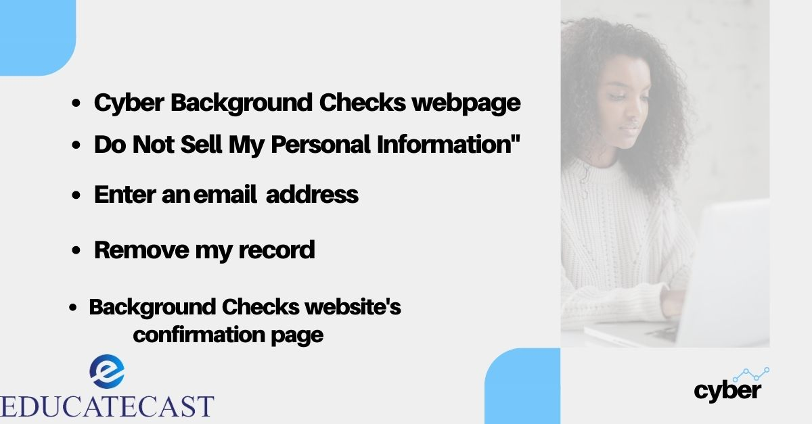

**Cyber-attacks and Background Checks**

Hackers can even affect background checks. Two government agencies in the United States halted background checks with a contractor last week after the business disclosed that its networks had been compromised in a cyber-attack. The attack appears to have started in a nation other than the United States. It's unknown how much information on federal employees may have been hacked.

The headquarters of **US Investigations Services (USIS)** are in Falls Church, Virginia. The corporation has engaged a computer forensics firm to investigate how and where the breach occurred.

All of this was enough for the government to act, most likely out of prudence. Contracts with USIS have been temporarily stopped by the **Office of Personnel Management (OPM)** and the **Department of Homeland Security (DHS).** The company intends to restore normal business operations soon.

USIS is a firm that takes advantage of government agencies' outsourcing of background checks. Background check activities were privatized by the OPM in 1996. USIS does background checks and investigations for the government. It also participates in other security-related investigations, such as those involving healthcare fraud.

USIS has been making headlines in recent months. The background check was carried out on Edward Snowden, the guy who released sensitive intelligence documents last year. USIS has also being investigated by the US Justice Department for allegedly cutting corners during the background check process.

In the background check procedure, there can be no shortcuts. Background checks and pre-employment screening are still essential components of the recruiting process. A thorough and dependable background check can protect a company from negligent hiring litigation. It also contributes to a safer working environment. Pre-employment tests also lower the chance of making the wrong hiring, which can have a negative impact on employee productivity and profitability. Don't skimp on the background check procedure. The danger is not worth it.

**Cyber Background Check FAQs**

1. **What may go wrong with a background check?**

What causes a background check to raise a red flag? A person may fail a background check for a variety of reasons, including criminal past, educational disparities, poor credit history, a damaged driving record, a fraudulent work history, and a failed drug test.

1. **What may go wrong with a background check?**

What causes a background check to raise a red flag? A person may fail a background check for a variety of reasons, including criminal past, educational disparities, poor credit history, a damaged driving record, a fraudulent work history, and a failed drug test.

1. **What causes a background check to take longer?**

The most typical reason of delays is when staffing agencies submit background check request forms that are incomplete or incorrect. When seeking background checks, the Fair Credit Reporting Act (FCRA) specifies specific rules that must be followed.

1. **How can you fool a background check?**

3 Ways Applicants Cheat on Their Background Check Reports and How to Avoid Them

Completed, bought, or no degree at all.

Giving a false birth date in order to prevent a criminal record on the report.

Making up professional experience with a false job.

1. **Is it true that background checks uncover everything?**

The short answer is no. A background check cannot provide a list or database of positions held by a professional over the years. The majority of pre-employment background check services are designed to unearth public record information, such as criminal histories, driving records, and credit history.

**In conclusion:**

It might be tough to find a reliable background check supplier online. Many websites promise to provide the greatest records but end up providing outdated information.

CyberBackgroundCheck.com is a completely free and safe website. If you want your information deleted from the website, follow the actions outlined in this article.